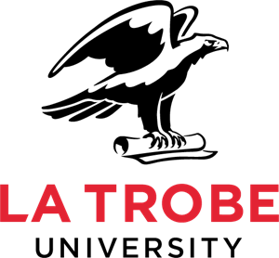

A research project about Radiotherapy and
people who have Learning Disabilities and cancer

Hello, my name is Charlotte Nutting
I am a research student and a Learning Disability Nurse and Social Worker.
This research project is about:
What Radiotherapy is like for people with Learning Disabilities who have cancer, and the family members, paid carers and professionals who support them.
‘Radiotherapy’ is a treatment that is used to treat cancer. It uses strong x-rays to kill cancer cells.
I would like to interview people with Learning Disabilities who have or have had cancer to find out about:
- how they were involved in making decisions about Radiotherapy.
- their experiences of Radiotherapy.
- how they were supported after Radiotherapy.

I would also like to interview paid carers, family members and professionals to find out about:
- their experiences supporting people who have Learning Disabilities and cancer with Radiotherapy.
To find out more about the project:
- Watch the short video: https://tinyurl.com/RTLDstudy
- Look at the study webpages & the easy read Information Sheet: https://tinyurl.com/IDandRadio

- You or a person who supports you can contact me:
Phone: 0114 2255989 Email c.nutting@shu.ac.uk
1

